1. INTRODUCTIPN

1.1 Overview

Designing virtual Zoom backgrounds involves creating visually appealing images or videos that users can set as their backdrop during Zoom meetings. These backgrounds can be themed, professional, or fun, and they should match the user's preferences and the context of the meeting. Key considerations include image resolution, lighting, and composition to ensure a seamless and attractive virtual background that doesn't distract from the meeting itself. It's important to create backgrounds that don't clash with the user's appearance and to use software that supports virtual backgrounds, like Zoom's built-in feature

1.2Purpose

Privacy: Virtual backgrounds can help protect your privacy by concealing your real surroundings, which may contain personal or sensitive information.

Branding: Organizations can use custom virtual backgrounds to reinforce their brand identity during video conferences.

Engagement: Creative and themed backgrounds can add an element of fun and engagement to meetings, making them more enjoyable and memorable.

Concealing Distractions: If your physical environment is cluttered or distracting, virtual backgrounds can help focus the meeting on the content rather than the backdrop.

**Problem definition & Design Thinking**

2.1 Empathy Map

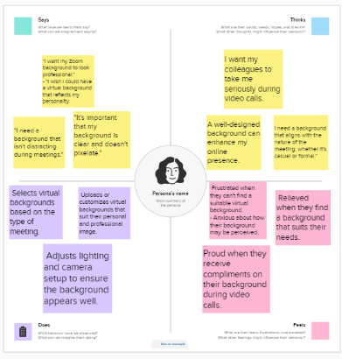

Link- <https://app.mural.co/t/ksowndaraselva2510/m/ksowndaraselva2510/1693480222074/0d9a90472d899260c871481efb7db0ba18a0751b?sender=u56ee0dd3d66090c11f006464>

2.2 Ideation & Brainstorming Map

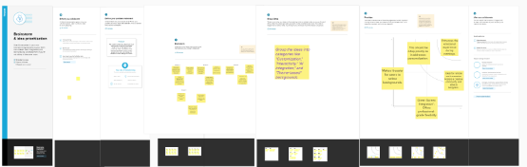

Link- <https://app.mural.co/t/ksowndaraselva2510/m/ksowndaraselva2510/1693804353364/6a5bfc56e354946da09966eed7145f29e66325f6?sender=u56ee0dd3d66090c11f006464>

**Result**

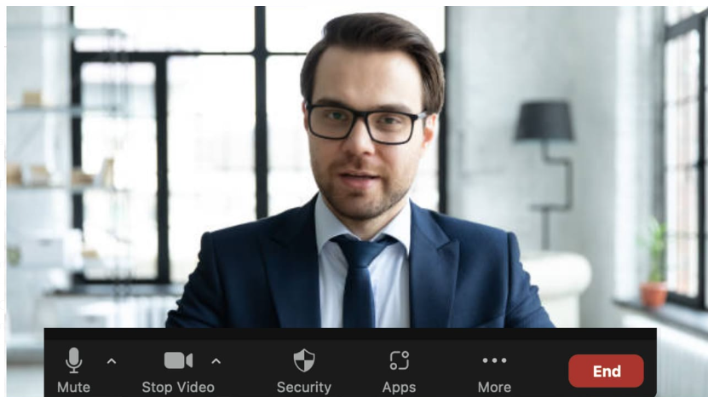

**Advantages & Disadvantages**

Advantages of Designing Virtual Zoom Backgrounds:

Privacy Protection: Virtual backgrounds conceal personal or sensitive information in the background, enhancing privacy.

Branding Opportunities: Organizations can reinforce their brand identity by using custom virtual backgrounds.

Creative Engagement: Themed or creative backgrounds can make meetings more engaging and enjoyable

Disadvantages of Designing Virtual Zoom Backgrounds:

Technical Requirements: Virtual backgrounds may require adequate system resources and a compatible device, which not all users have.

Realistic Appearance: Achieving a seamless and realistic virtual background can be challenging, depending on lighting and camera quality.

Compatibility Issues: Some video conferencing platforms may not fully support virtual backgrounds, limiting their use.

**APPLICATIONS**

The areas where the solution applied and the used application are for **The Task 1was complete in the mural app, Next task 2 where create in the Canva app**.

:Virtual backgrounds can be employed in government and public meetings to maintain a professional and secure environment for officials.In essence, the application of designing virtual Zoom backgrounds is versatile and extends to a wide range of professional, educational, and recreational settings where video conferencing and virtual meetings are prevalent.

**CONCLUSION**

In conclusion, the practice of designing virtual Zoom backgrounds offers a versatile solution for enhancing the virtual meeting experience across various domains. By creating visually appealing and context-appropriate backgrounds, users can achieve a range of benefits, including enhanced professionalism, privacy protection, and branding opportunities. Additionally, virtual backgrounds allow for creative engagement, distraction mitigation, and personal expression, making them a valuable tool for today's remote and online communication needs.

However, it's important to consider the potential disadvantages, such as technical requirements, concerns about authenticity, and the risk of distraction when employing dynamic backgrounds. These factors should be weighed against the advantages to determine the most effective use of virtual backgrounds in different situations.

**FUTRE SCOPE**

In the future, there are several enhancements that can be made to the practice of designing virtual Zoom backgrounds to further improve the user experience and functionality:

AI-Based Background Removal: Advanced AI technology could automatically and accurately remove the user's real background without the need for a green screen, making it more accessible and user-friendly.

3D and Interactive Backgrounds: The development of 3D and interactive virtual backgrounds could create more immersive meeting experiences, allowing users to engage with the environment in unique ways.

Environmental Responsiveness: Virtual backgrounds that adapt to the user's speech, gestures, or emotions could add a new layer of interactivity and personalization to virtual meetings.

Custom Animation Tools: Offering users the ability to create custom animations for their backgrounds could lead to more creative and engaging virtual environments.

**APPENDIX**

The appendix will contain additional resources, links, or templates related to Canva and Personalized Invitation Using Canva. This section will include

Canva official link

<https://www.canva.com>

Background Template



USED FONDS

Back ground

Pictures

Images

START FOUND

